
Symbiosis Institute of Technology, Pune
Faculty of Engineering
CSE- Academic Year 2026-27
Java Programming – Lab Batch 2024-28
Lab Assignment No: - 21
Name of Student: Sanika Botre
PRN No.: 25070122063
Batch: 2025-29
Class: CSE A-2
Academic Year & Semester: 2026 & 3rd Semester
Date of Submission
Title of Assignment: Demonstration and exploration of JDBC classes and interfaces (DriverManager, Connection, Statement).

Learning Objectives:
To understand and use the core JDBC classes for database connectivity.
Theory:
The JDBC API consists of several classes and interfaces that facilitate database connectivity. The DriverManager class is responsible for loading the appropriate JDBC driver and establishing a connection with the database using a database URL, username, and password. The Connection interface represents an active session between the Java application and the database server. It provides methods to create SQL statements and manage transactions. The Statement interface executes static SQL queries and updates. These classes work together to establish communication between Java programs and databases. Understanding these core components is essential for developing database applications using Java.
Practice questions
1. Create a program to connect Java with database and display database connection status.
Code:
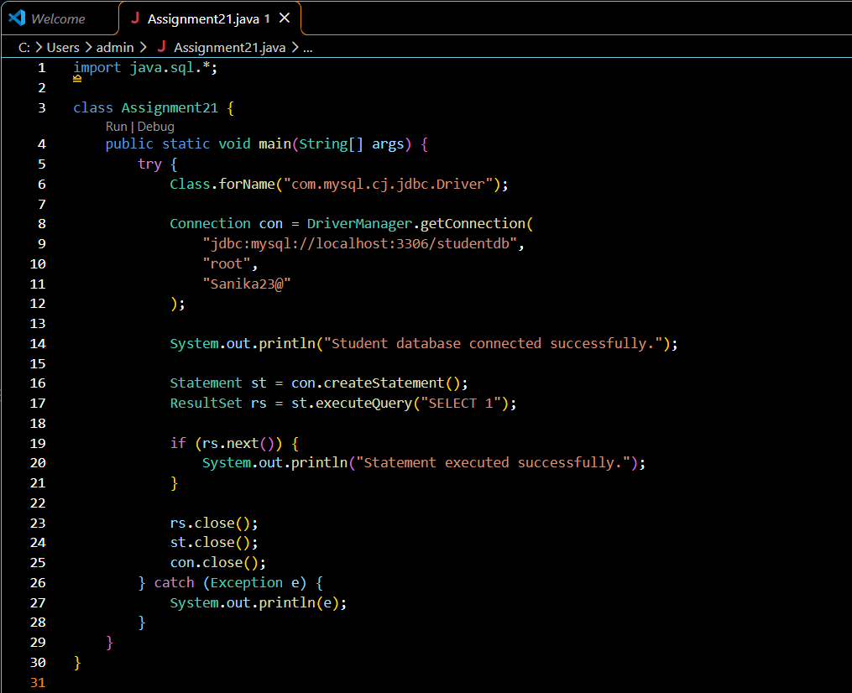

Output:
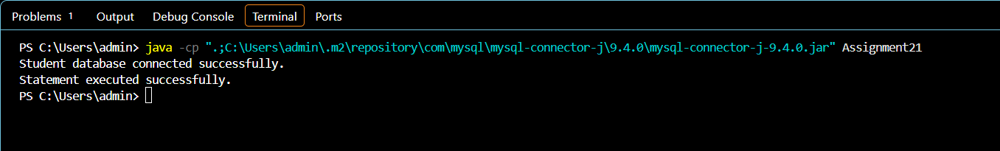

2. Create a Java program to connect with a database and display the connection status. After successful connection, show a message indicating that the Student database is connected successfully.
Code:
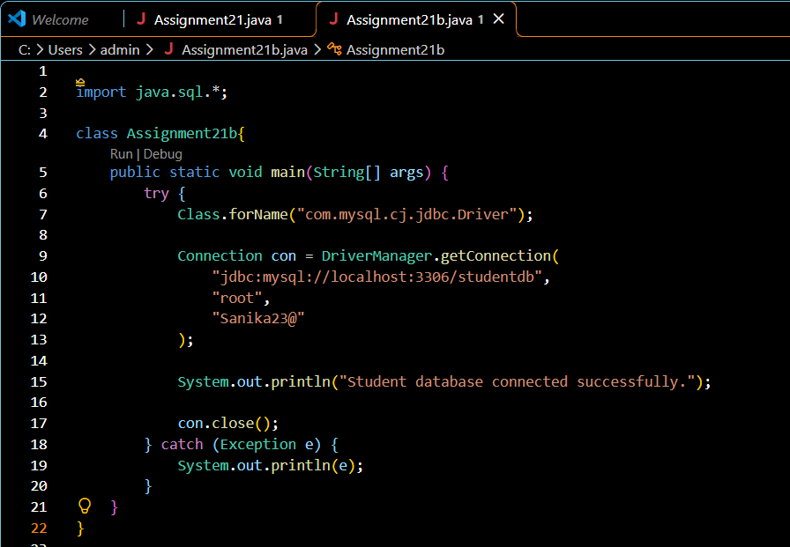

Output:
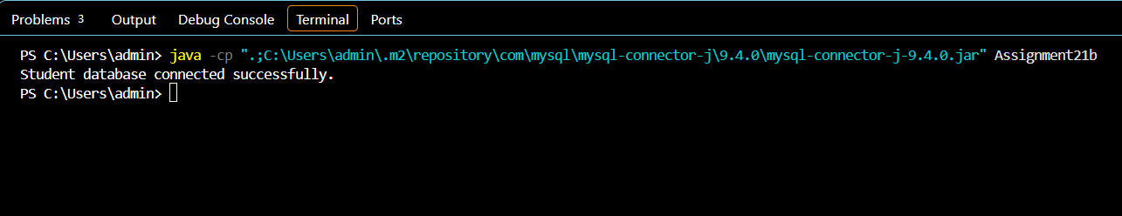

Conclusion
Thus, the Java program was executed successfully and established a connection with the Student database using JDBC. The connection status was displayed using a success message. This experiment demonstrates how Java applications connect to MySQL databases using the JDBC API and how database connections can be closed after use.

